**Maintaining your Individual and Institutional FDP Profiles**

The document will instruct you how to:

* Find your FDP Profile and associated Institutional Email Address
* Log in to FDP website and edit Profile
* Create a New FDP profile if you do not already have one
* Reset your FDP Profile password
* Add/Update Official Administrative, Faculty, and Technical Representatives

You must belong to an FDP Member Organization to have and edit profiles. You will be asked to select a representative type in your profile. FDP Institutional Members each have three official representatives, one Official Administrative Representative, One Official Faculty Representative, and one Official Technical Representative. Other representatives from the institution should identify themselves as the regular version of each of these representative types.

**Find Your FDP Profile and Institutional Email Address**

* From the FDP Homepage, select “Directory” and “Search People”

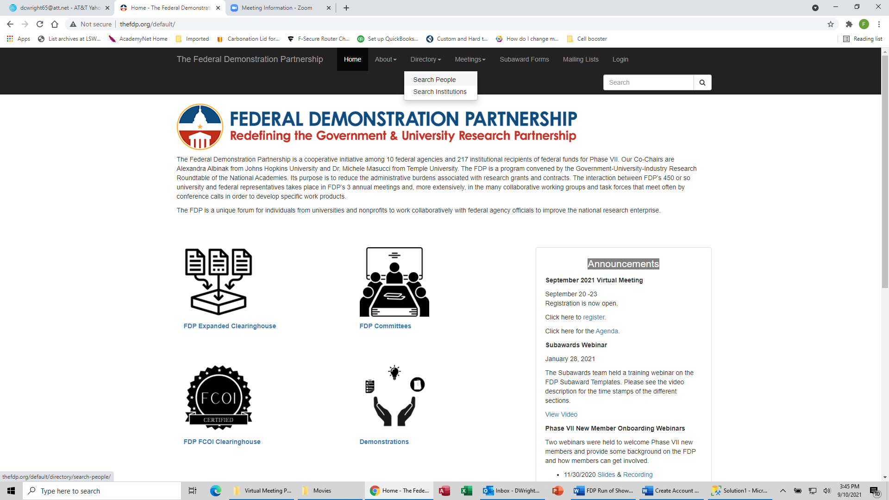

* Enter your name and then click the Search button.

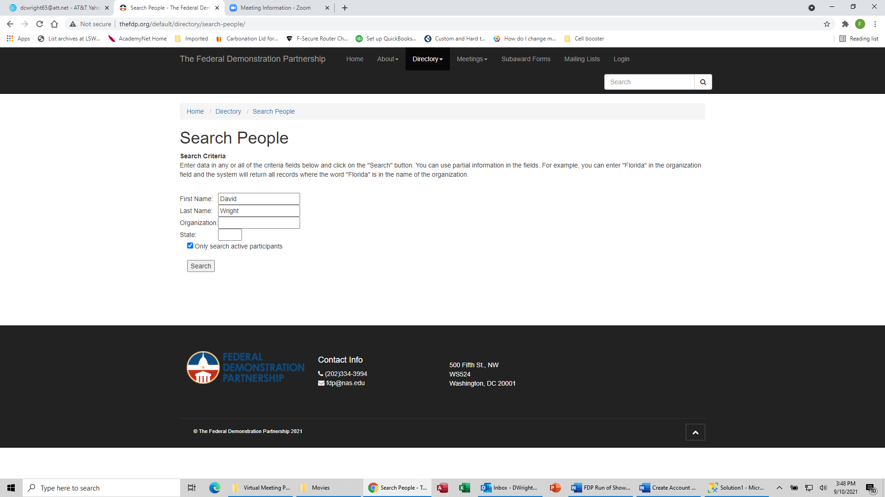

* Click on your name.

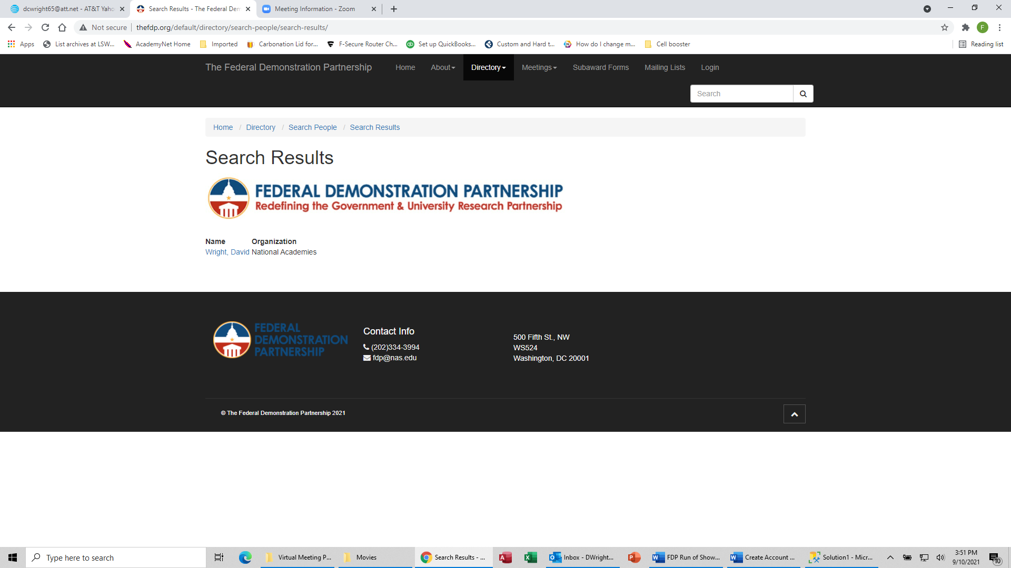

* View profile to see email address that is in the system

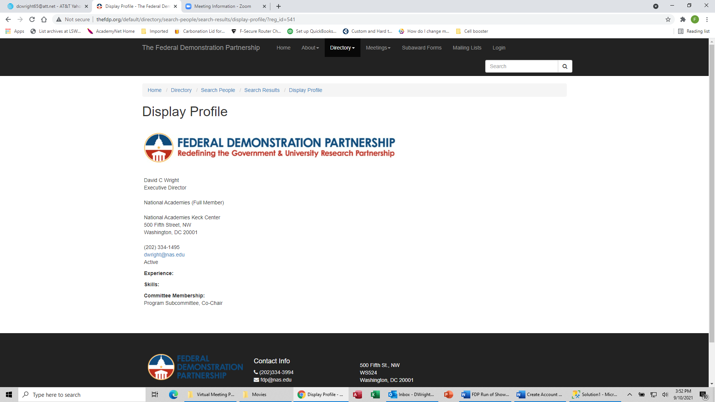

**Login to FDP Web Site and Edit Profile**

* Click “Login” at the top right of the FDP homepage

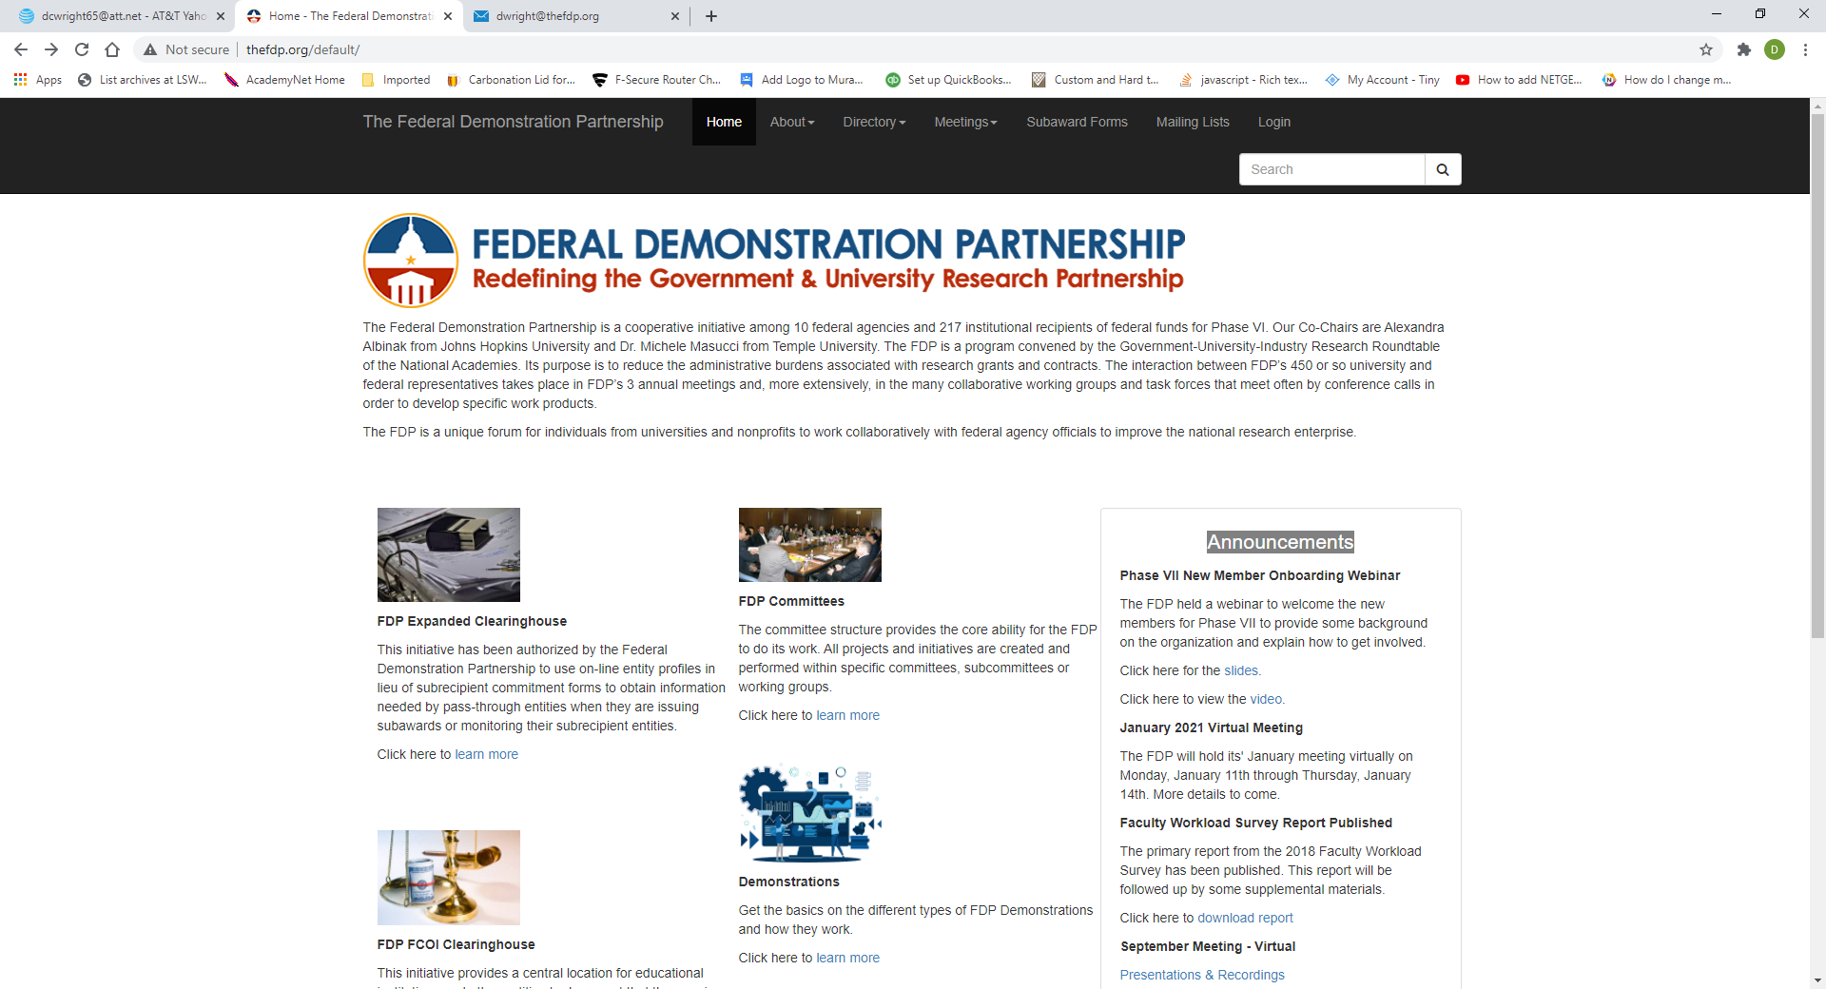

Enter your user ID, password and click the “Login” button.

* Click the “Edit Profile” link

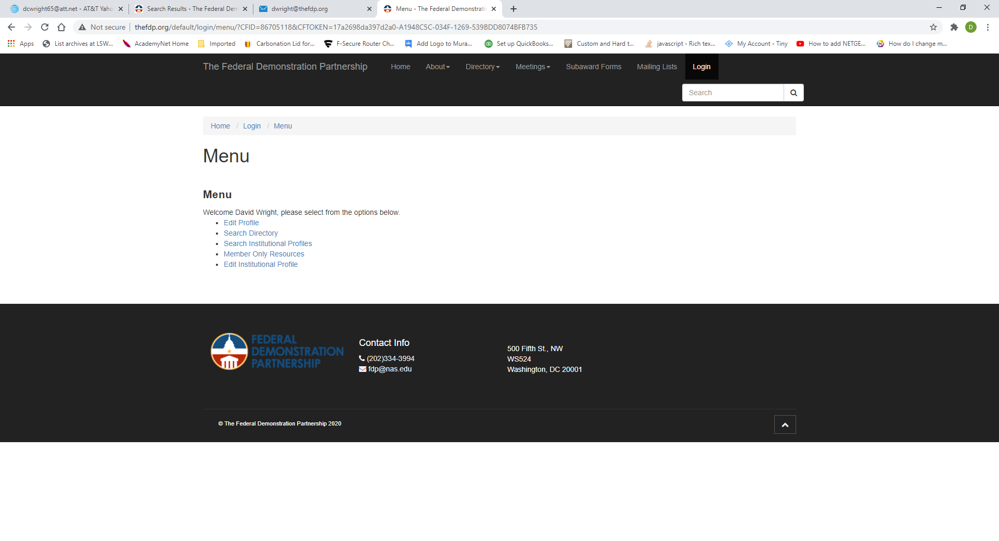

* Update the profile as needed. You can also update your institutional email address
* You can make multiple selections in the Experience and Skills sections
* Click the “Update Profile” button at the bottom of the page

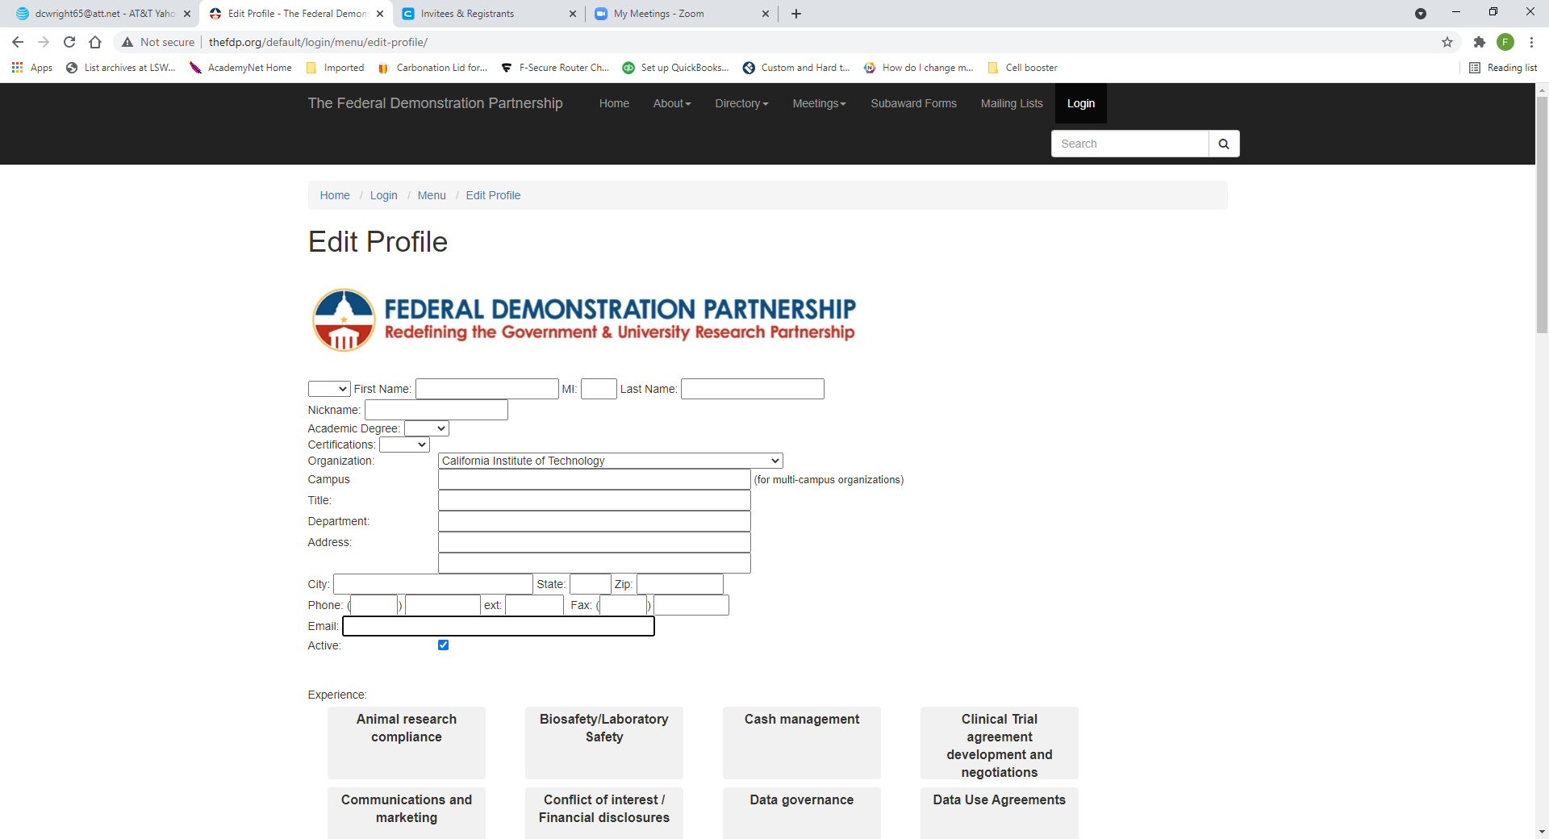

**Create a New Profile on FDP Web Site**

* First verify that you do not already have a profile by searching for your name (instructions at the top of this document). If you already have a profile, use the edit feature
* Click “Login” at the top right of the FDP homepage

* Click “Create New Account”

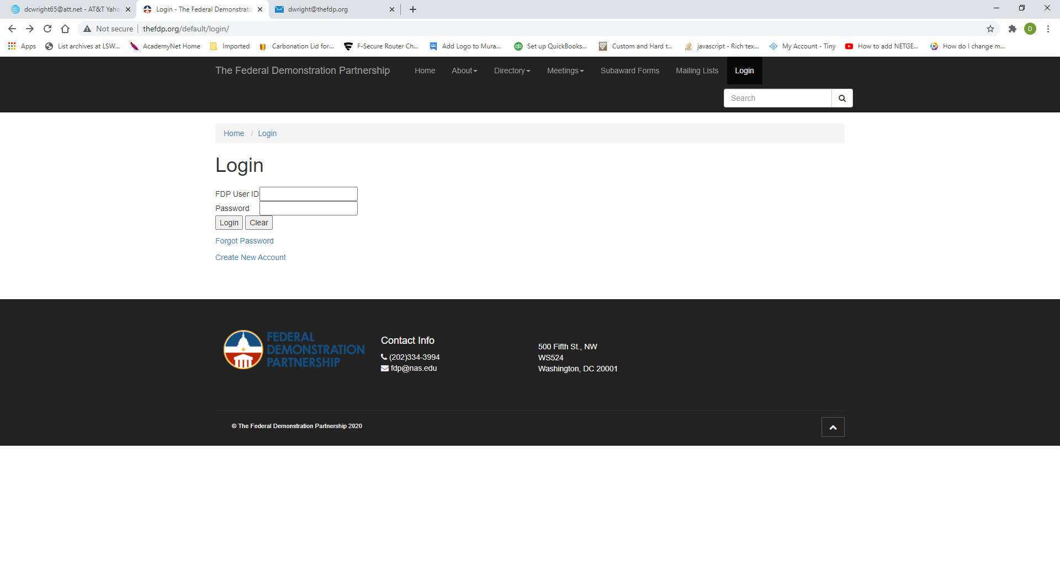

* Select your user ID. If you pick one that is already in use you will be prompted to select a different one.
* Enter the rest of the information and click the “Create Profile” button

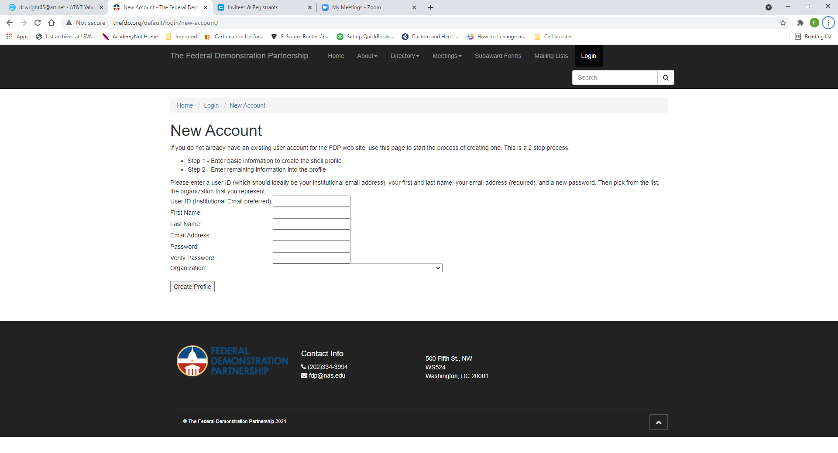

* Click the “Edit Profile Link”

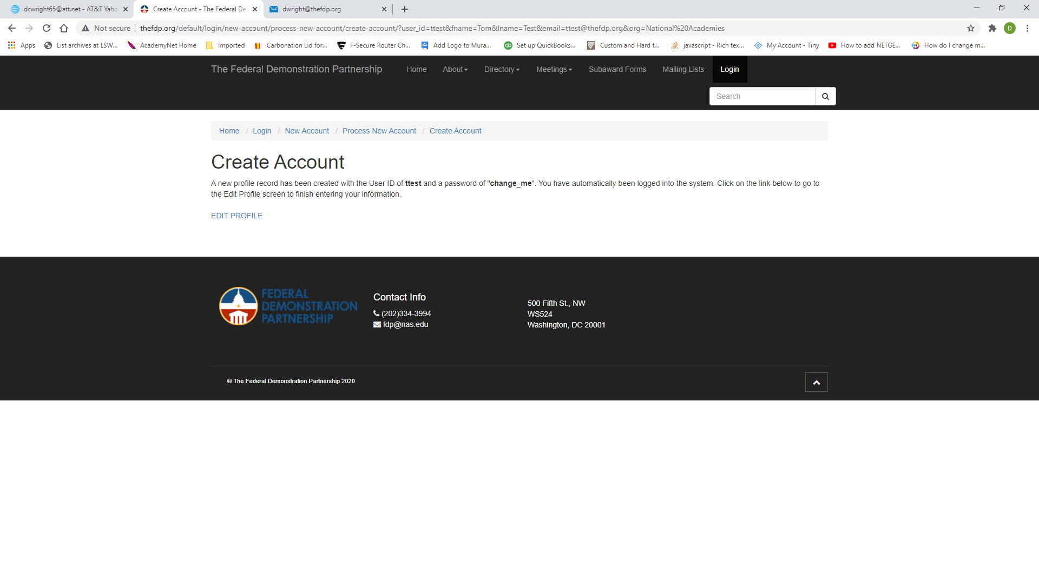

* Complete the rest of the profile
* You can make multiple selections in the Experience and Skills sections
* Click the “Update Profile” button at the bottom of the page



**Reset Your FDP Profile Password**

* Go to login screen and click the “Forgot Password” link

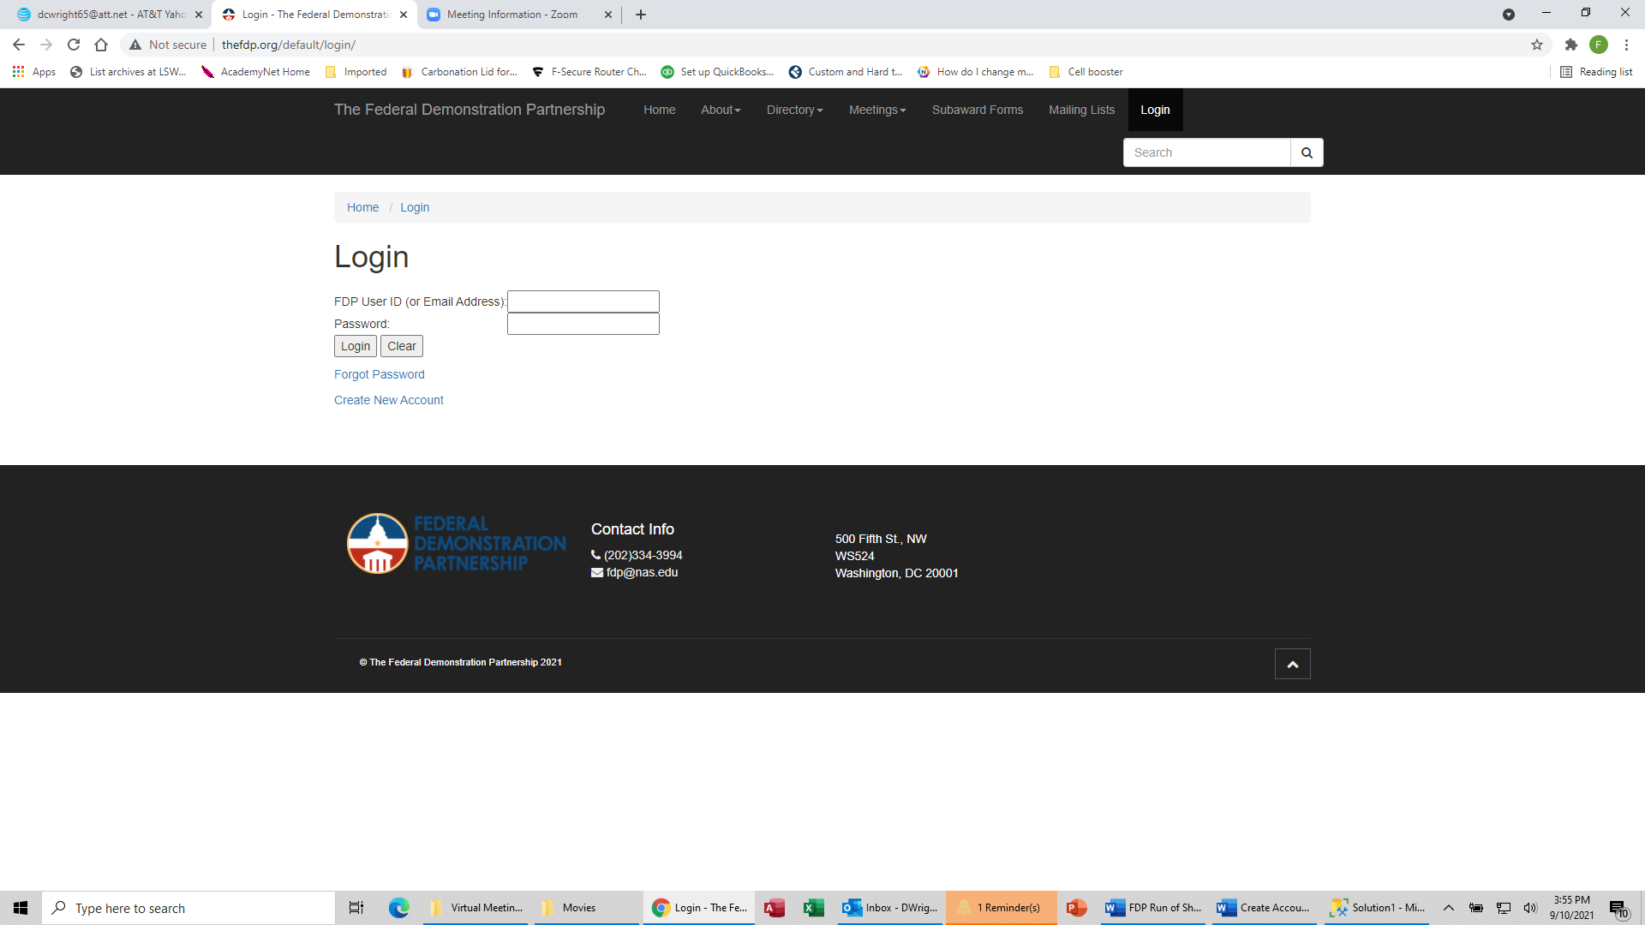

* Enter your logon ID or your email address (check directory listing instructions above to find your username and institutional email address) and click the “Reset Password” button

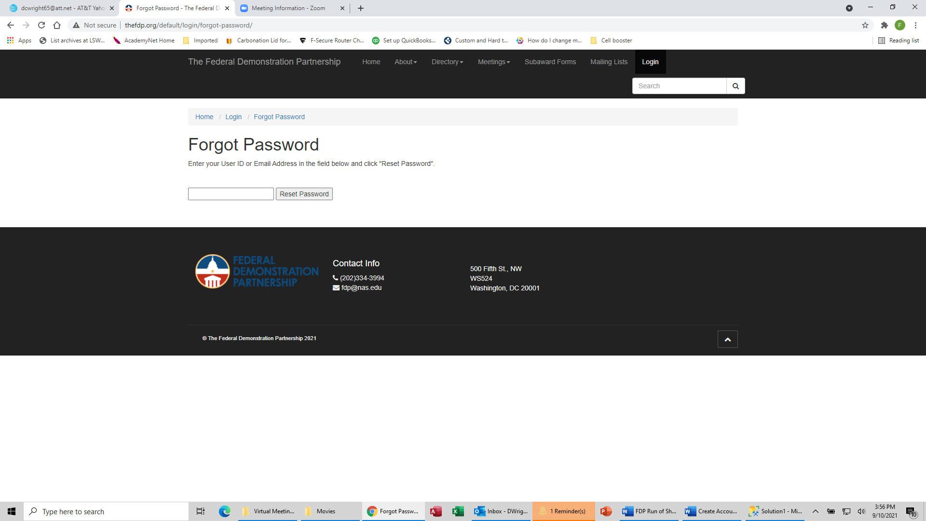

* An email will be sent to the email address in the account with a link to reset the password.

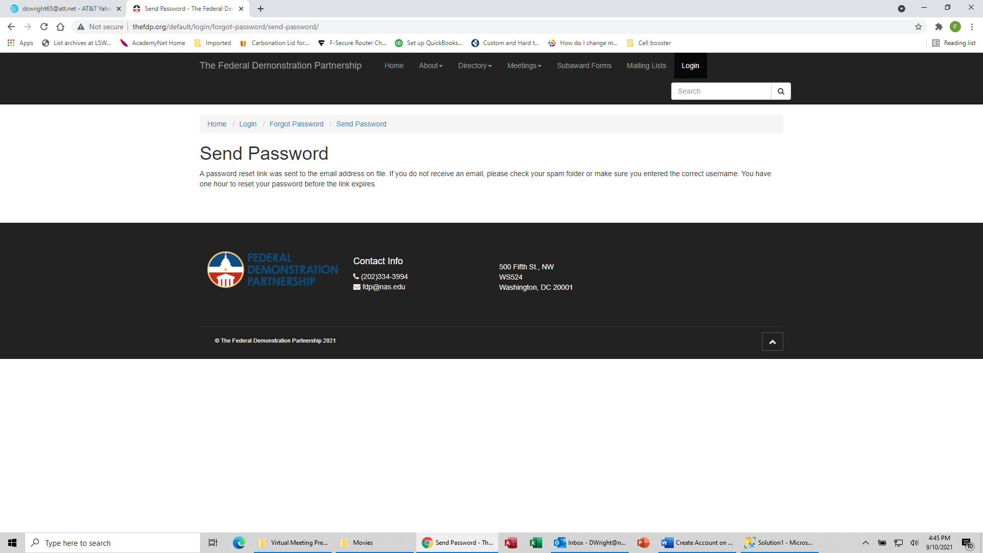

* Enter your new password in both fields and click the “Set Password” button.

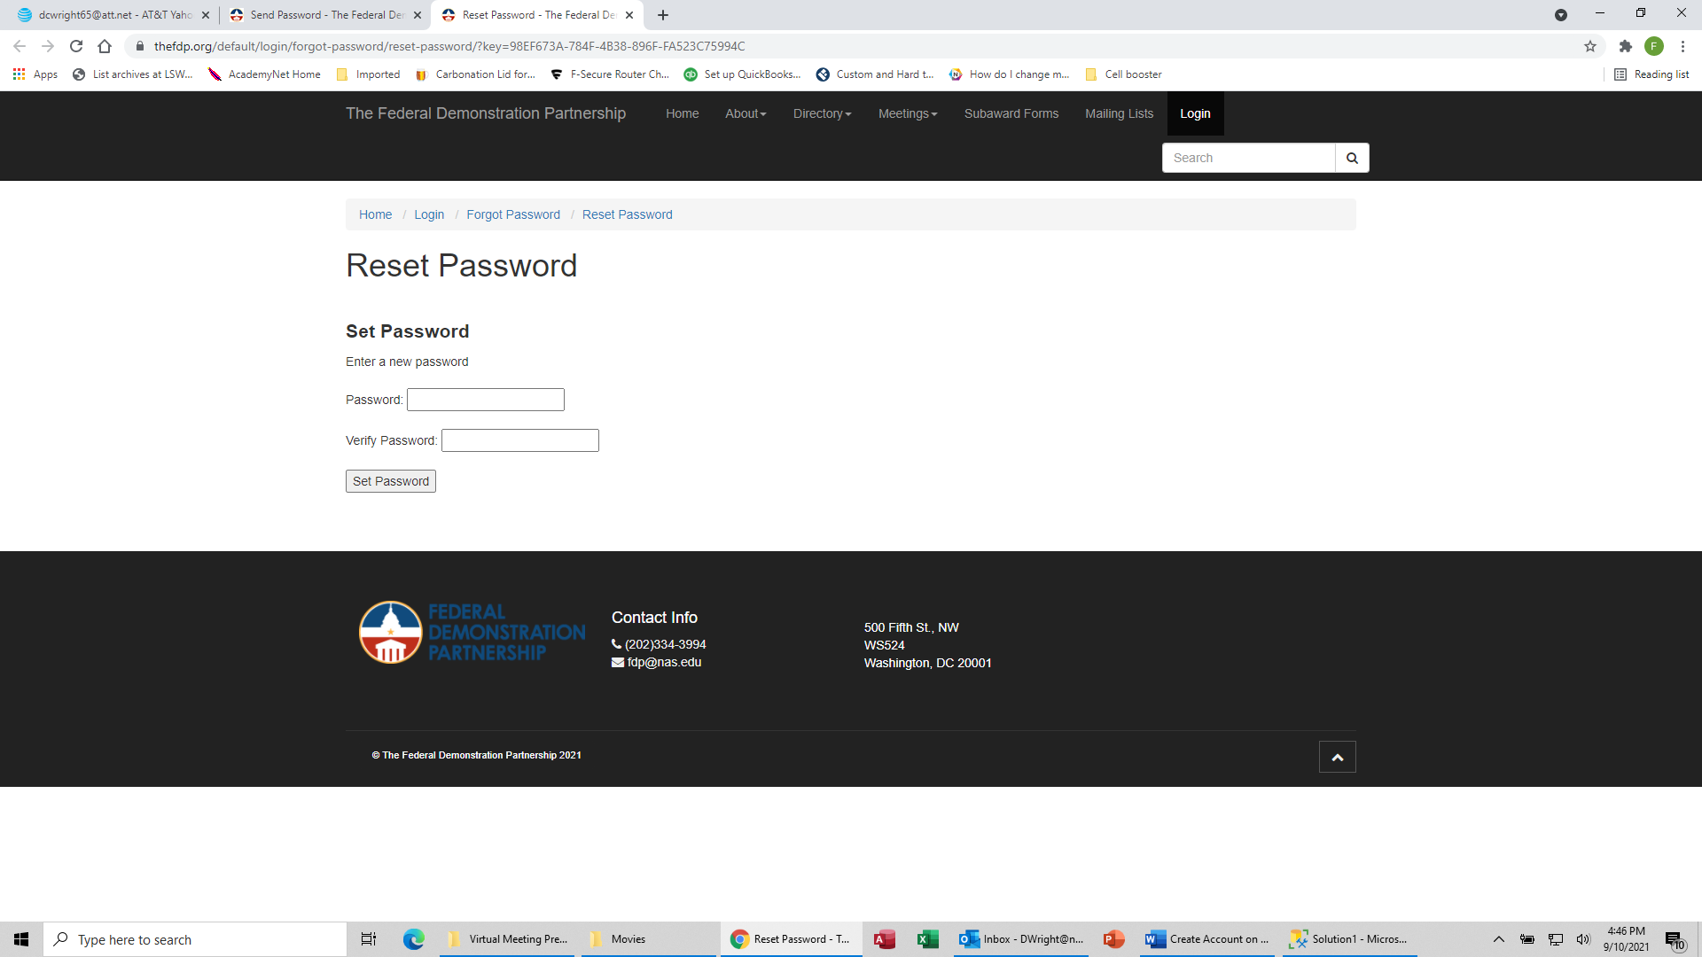

* Once the reset is complete, click the link to go back to the login page.

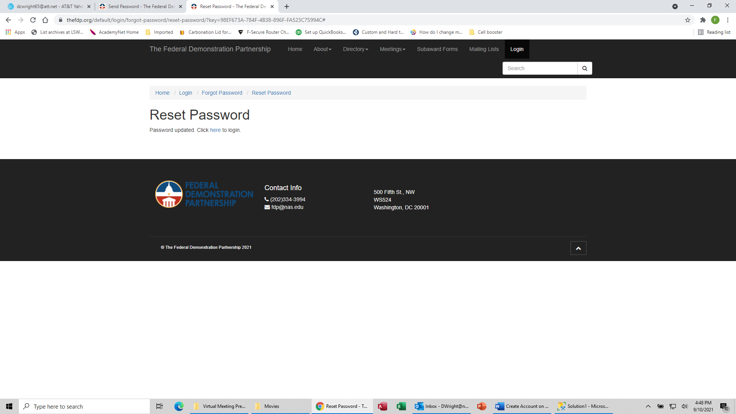

**Add/Update Official Administrative, Faculty and Tech Reps**

Note: Only the named Official Administrative Rep can make these assignments. Each of these reps will need to have created their profiles, using the steps above, before the Official Administrative Rep will be able to make the linkage between office representative profiles and the institutional profile.

* As the Official Administrative Representative, Click “Login” at the top right of the FDP homepage



* Enter your user ID, password and click the “Login” button. You can verify your username/institutional email using the process at the top of this document.



* Click the “Edit Institutional Profile” link



* Select the appropriate person from the dropdown field for the representative whom you are assigning.

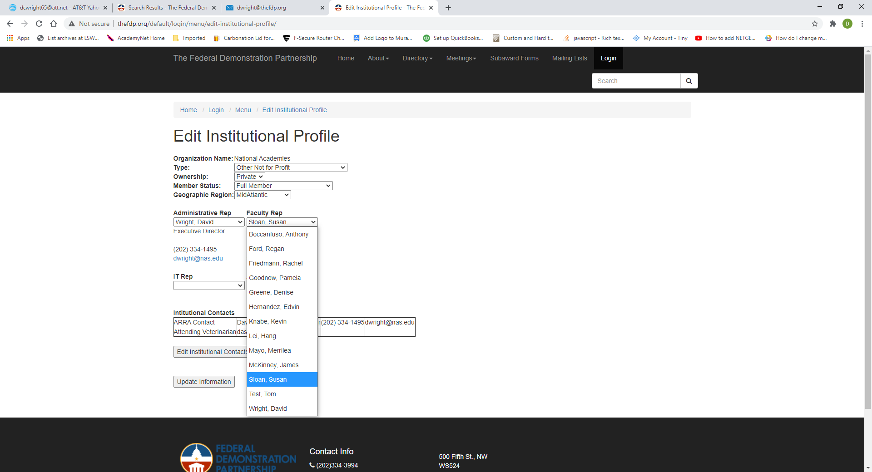

Click the “Update Information” button.

